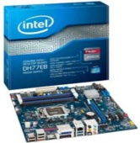 | Intel DH77EB Motherboard | - Micro-ATX Form Factor  - LGA 1155 Socket Type  - Intel H77 Chipset  - RAID Controller: Intel H77 Chipset  - 4 Memory Slots  - Maximum 32 GB DDR3  - Dual Channel DIMM Memory | Rs. 6930 | 0 | Rs. 6930
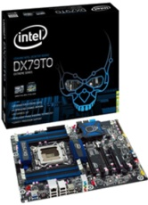 | Intel DX79TO Motherboard | - ATX Form Factor  - LGA2011 Socket Type  - Intel X79 Express Chipset  - RAID Controller: Intel X79 Express Chipset  - 8 memory Slots  - Maximum 64 GB DDR3  - Dual Channel DIMM Memory | Rs. 17280 | 0 | Rs. 17280
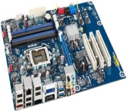 | Intel DH67CL Motherboard | - ATX Form Factor  - LGA 1155 Socket Type  - Intel H67  - 4 Memory Slots  - Maximum 32 GB DDR3  - Dual Channel DIMM Memory  - 1 HDMI Ports | Rs. 13900 | 20 | Rs. 10999
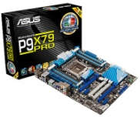 | ASUS P9X79 PRO Motherboard | - ATX Form Factor  - LGA 2011 Socket Type  - Intel X79 Chipset  - Raid Controller: Intel X79  - 8 Memory Slots  - Maximum 64 GB DDR3  - Quad Channel DIMM Memory | Rs. 30300 | 15 | Rs. 25699
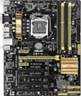 | Asus Z87-K Motherboard | - Intel Z87 Chipset  - Dual Channel DIMM Memory  - ATX Form Factor  - 4 Memory Slots  - 1 HDMI Port  - LGA 1150 Socket Type  - Maximum 32 GB DDR3 | Rs. 14925 | 16 | Rs. 12518
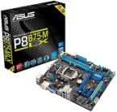 | ASUS P8B75-M LX Motherboard | - 2 Memory Slots  - Intel B75 Chipset  - Micro-ATX Form Factor  - LGA 1155 Socket Type  - Maximum 16 GB DDR3  - Dual Channel DIMM Memory  - 5 SATA 3Gb/s Headers with Intel B75 chipset Controller | Rs. 6000 | 5 | Rs. 5690
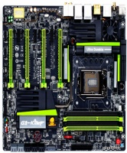 | Gigabyte G1 Sniper 5 Moherboard | - E-ATX Form Factor  - Marvell 88SE9230  - LGA 1150 Socket Type  - Intel Z87 Chipset  - Maximum 32 GB DDR3  - 4 Memory Slots  - RAID Controller: Intel Z87  - Dual Channel DIMM Memory | Rs. 36180 | 0 | Rs. 36180
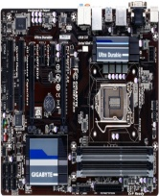 | Gigabyte H87-D3H Motherboard | - Dual Channel DIMM Memory  - ATX Form Factor  - Intel H87 Chipset  - Maximum 32 GB DDR3  - 1 HDMI Port  - LGA 1150 Socket Type  - 4 Memory Slots | Rs. 14999 | 38 | Rs. 9150
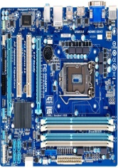 | Gigabyte GA-B75M-D3H Motherboard | - Micro-ATX Form Factor  - LGA 1155 Socket Type  - Intel B75 Express Chipset  - 4 Memory Slots  - Maximum 32 GB DDR3  - Dual Channel DIMM Memory  - 1 HDMI Ports | Rs. 4850 | 0 | Rs. 4850
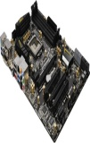 | ASRock Z77 Extreme4 Motherboard | - ATX Form Factor  - LGA 1155 Socket Type  - Intel Z77 Chipset  - RAID Controller: Intel Z77 Chipset  - 4 Memory Slots  - Maximum 32 GB DDR3  - Dual Channel DIMM Memory | Rs. 17100 | 29 | Rs. 12100
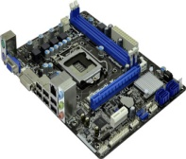 | ASRock H71M-DGS Motherboard | - Micro-ATX Form Factor  - LGA 1155 Socket Type  - 2 Memory Slots  - Maximum 16 GB DDR3  - Intel H61 Chipset  - Dual Channel DIMM Memory  - 5.1 Audio I/O Channels | Rs. 4990 | 30 | Rs. 3475
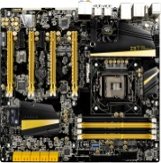 | ASRock Z87 OC Formula Motherboard | - ntel Z87 Chipset  - 4 Memory Slots  - 2 HDMI Port  - E-ATX Form Factor  - Dual Channel DIMM Memory  - LGA 1150 Socket Type  - Maximum 32 GB DDR3 | Rs. 28812 | 0 | Rs. 28812

